Report on

**Dynamic Server Allocation as Fail Safe Mechanism**

Class - D17B

Karuna Hasani(31)

Kunal Dodeja(21)

Ajinkya Gutti(29)

**ABSTRACT**

There are some situations when ip address of your primary server fails to load and you don't want to miss your visitors and what we have come up with the idea of generating a secondary server and the visitors will be redirected to secondary server with an floating ip address. Logs of all the failures to primary servers will be generated and stored along with the secondary server’s logs.

High availability is a function of system design that allows an application to automatically restart or reroute work to another capable system in the event of a failure. In terms of servers, there are a few different technologies needed to set up a highly available system. There must be a component that can redirect the work and there must be a mechanism to monitor for failure and transition the system if an interruption is detected.

The keepalived daemon can be used to monitor services or systems and to automatically failover to a standby if problems occur. We will configure a [floating IP address](https://www.digitalocean.com/community/tutorials/how-to-use-floating-ips-on-digitalocean) that can be moved between two capable web servers. If the primary server goes down, the floating IP will be moved to the second server automatically, allowing service to resume.

**INTRODUCTION**

Before starting of with the actual implementation there are primary concepts which needs to be understood and prerequisite should be configured before starting up with the project’s implementation.

**What is virtual server?**

On the Internet, a virtual server is a server (computer and various server programs) at someone else's location that is shared by multiple Web site owners so that each owner can use and administer it as though they had complete control of the server. Some Internet service providers (ISPs) offer a virtual server service instead of, or in addition to, virtual hosting. Using a virtual server, a company or individual with a Web site can not only have their own domain name and IP address, but can administer their own file directories, add email accounts and address assignments, assign multiple domain names that resolve to a basic domain name without involvement from the ISP, manage their own logs and statistics analysis, and maintain passwords. Users of a virtual server, however, do not have to manage the hardware aspects of running a server and effectively share the cost of expensive line connections to the Internet.

**IMPLEMENTATION DETAILS**

**Prerequisites**

In order to complete this guide, you will need to create two Ubuntu 14.04 servers on your DigitalOcean account. Both servers must be located within the same datacenter and should have private networking enabled.On each of these servers, you will need a non-root user configured with sudo access. You can follow our [Ubuntu 14.04 initial server setup guide](https://www.digitalocean.com/community/tutorials/initial-server-setup-with-ubuntu-14-04) to learn how to set up these users.When you are ready to get started, log into both of your servers with your non-root user.

**To Create Your First DigitalOcean Droplet Virtual Server**

DigitalOcean calls its virtual private servers Droplets; each Droplet that you spin up is a new VPS for your personal use.

***Step One — Log In***

To create your first Droplet go to the [DigitalOcean Control Panel](https://cloud.digitalocean.com/Droplets) and log in with your email and password. The create button will be right there on the first page: click on "Create Droplet":

***Step Two — Select Droplet Image***

You can create your Droplet image from 4 possible categories.

***Step Three — Select Your Droplet's Size***

Depending on your needs and budget, you can select the Droplet option that works best for you.

***Step Four — Select Your Droplet Region***

You may choose the most effective region for your Droplet location. Although equally powerful, the best region to choose is the one nearest to you and your customers or other possible users. Selecting a more distant server location may increase your server latency without serving any practical purpose.

***Step Five — Select Additional Options***

The Select additional options section allows you to select which features you would like your

***Step Six — Select SSH Keys (Optional)***

Optional: Select which SSH keys you would like to add to your new Droplet.

It is recommended that you set up SSH keys to authenticate to your Droplets because it provides better security than a basic password.

***Step Seven — Select the Number and Names of the Droplets to Create***

Next, you can choose the number and names of the Droplets you wish to create. Depending on the number of Droplets currently in your account, you can create up to five Droplets that will use the configuration that you have selected. By default, a single Droplet is set to be created. You can adjust the number of Droplets to create be clicking the plus or minus buttons.

***Step Eight — Create Your Droplet***

Once you have selected all of your preferred options, click on "Create".After your Droplet is created, its root password will arrive in your email inbox and the Droplet will be set up. If you included an SSH key in the previous steps, you will not be emailed a root password — use your SSH private key to authenticate as the root user instead.

With that, your server is ready!

**Initial Server Setup with Ubuntu 14.04**

When you first create a new Ubuntu 14.04 server, there are a few configuration steps that you should take early on as part of the basic setup. This will increase the security and usability of your server and will give you a solid foundation for subsequent actions.

***Step One — Root Login***

To log into your server, you will need to know your server's public IP address and the password for the "root" user's account. If you have not already logged into your server, you may want to follow the first tutorial in this series, [How to Connect to Your Droplet with SSH](https://www.digitalocean.com/community/tutorials/how-to-connect-to-your-droplet-with-ssh), which covers this process in detail.

If you are not already connected to your server, go ahead and log in as the root user using the following command (substitute the highlighted word with your server's public IP address):

local $ssh root@SERVER_IP_ADDRESS

***Step Two — Create a New User***

Once you are logged in as root, we're prepared to add the new user account that we will use to log in from now on. #adduser demo

***Step Three — Root Privileges***

Now, we have a new user account with regular account privileges. However, we may sometimes need to do administrative tasks.:

# gpasswd -a demo sudo

***Step Four — Add Public Key Authentication (Recommended)***

The next step in securing your server is to set up public key authentication for your new user. Setting this up will increase the security of your server by requiring a private SSH key to log in.

Generate a Key Pair

To generate a new key pair, enter the following command at the terminal of your local machine (ie. your computer):

local $ssh-keygen

***Step Five — Configure SSH Daemon***

Begin by opening the configuration file with your text editor as root:

# nano /etc/ssh/sshd_config.

***Step Six -- Reload SSH***

Now that we have made our change, we need to restart the SSH service so that it will use our new configuration.

Type this to restart SSH:

# service ssh start.

For the server that we showed you how to configure above, you would connect using this command. Substitute your own user name and server IP address where appropriate:

ssh demo@SERVER_IP_ADDRESS

At this point, you have a solid foundation for your server. You can install any of the software you need on your server now.

**To Set Up Highly Available Web Servers with Keepalived and Floating IPs on Ubuntu 14.04**

***Install and Configure Nginx***

Start off by updating the local package index on each of your servers. We can then install Nginx:



In most cases, for a highly available setup, you would want both servers to serve exactly the same content. However, for the sake of clarity, in this guide we will use Nginx to indicate which of the two servers is serving our requests at any given time. To do this, we will change the default index.html page on each of our hosts. Open the file now:



On your first server, replace the contents of the file with this:

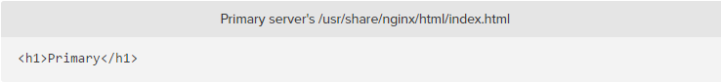

On your second server, replace the contents of the file with this:

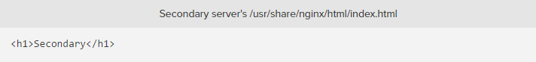

***Build and Install Keepalived***

Next, we will install the keepalived daemon on our servers. There is a version of keepalived in Ubuntu's default repositories, but it is outdated and suffers from a few bugs that prevent our configuration from working. Instead, we will install the latest version of keepalived from source.



Once the dependencies are in place, we can download the tarball for keepalived. Visit [this page](http://www.keepalived.org/download.html) to find the latest version of the software. Right-click on the latest version and copy the link address. Back on your servers, move to your home directory and use wget to grab the link you copied:



Use the tar command to expand the archive and then move into the resulting directory:

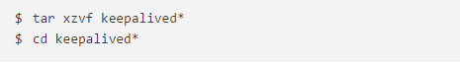

Build and install the daemon by typing:

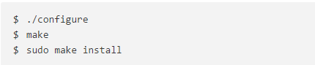

The daemon should now be installed on the system.

Create a Keepalived Upstart Script

We can create a very simple Upstart script that can handle our keepalived service. Open a file called keepalived.conf within the /etc/init directory to get started:



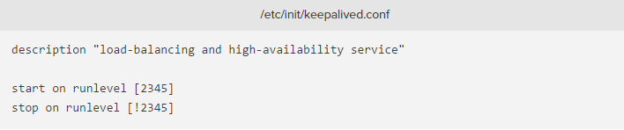

Because this service is integral to ensuring our web service remains available, we want to restart this service in the event of a failure. We can then specify the actual exec line that will start the service. We need to add the --dont-fork option so that Upstart can track the pid correctly:

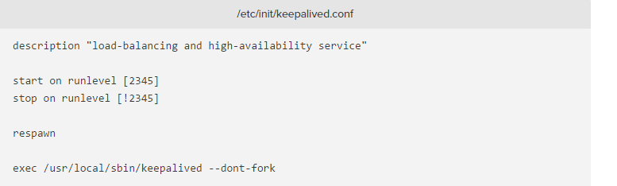

Create the Keepalived Configuration File

With our Upstart file in place, we can now move on to configuring keepalived.The service looks for its configuration files in the /etc/keepalived directory. Create that directory now on both of your servers:



Collecting the Private IP addresses of your Servers

Before we create the configuration file, we need to find the private IP addresses of both of our servers. On DigitalOcean servers, you can get our private IP address through the metadata service by typing:

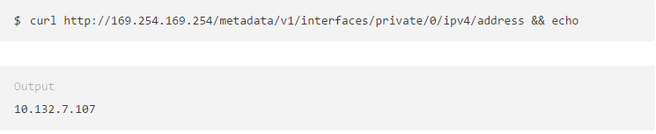

Creating the Primary Server's Configuration

Next, on your primary server, create the main keepalived configuration file. The daemon looks for a file called keepalived.conf inside of the /etc/keepalived directory:



Inside, we will start by defining a health check for our Nginx service by opening up a vrrp_script block. This will allow keepalived to monitor our web server for failures so that it can signal that the process is down and begin recover measures.

Our check will be very simple. Every two seconds, we will check that a process called nginx is still claiming a pid:

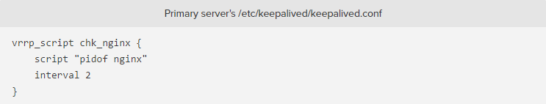

Next, we will open a block called vrrp_instance. This is the main configuration section that defines the way that keepalived will implement high availability.

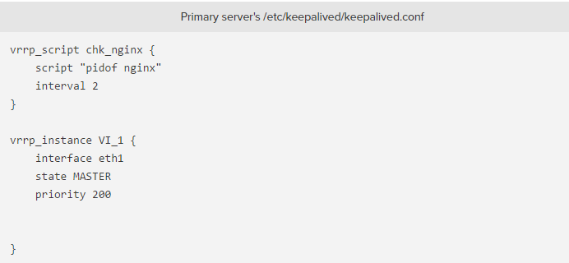

Next, we will assign an ID for this cluster group that will be shared by both nodes. We will use "33" for this example. We need to set unicast_src_ip to our primary server's private IP address that we retrieved earlier. We will set unicast_peer to our secondary server's private IP address:

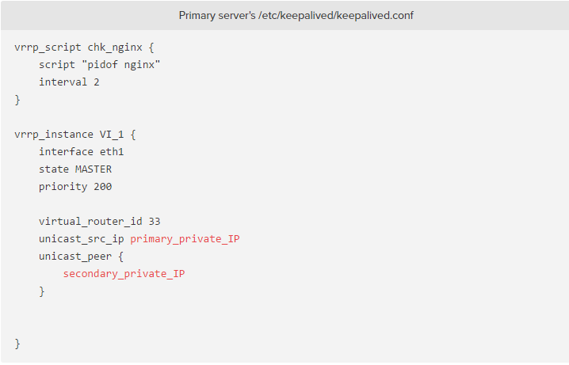

Next, we can set up some simple authentication for our keepalived daemons to communicate with one another. This is just a basic measure to ensure that the servers in question are legitimate. Create an authentication sub-block. Inside, specify password authentication by setting the auth_type. For the auth_pass parameter, set a shared secret that will be used by both nodes. Unfortunately, only the first eight characters are significant:  
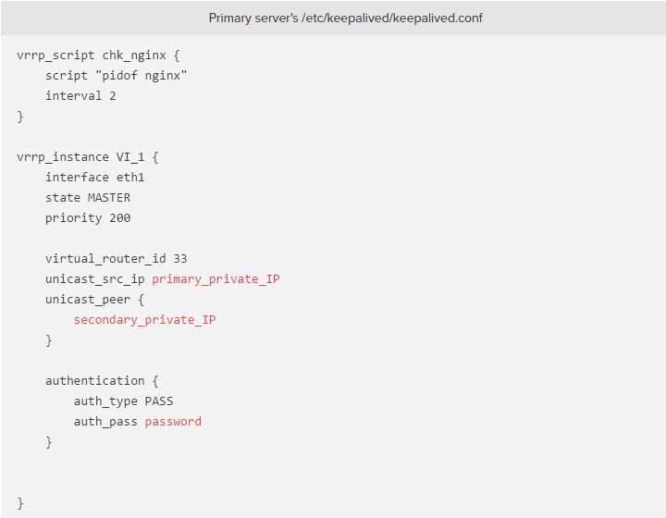

Next, we will tell keepalived to use the routine we created at the top of the file, labeled chk_nginx, to determine the health of the local system. Finally, we will set a notify_master script, which is executed whenever this node becomes the "master" of the pair. This script will be responsible for triggering the floating IP address reassignment. We will create this script momentarily: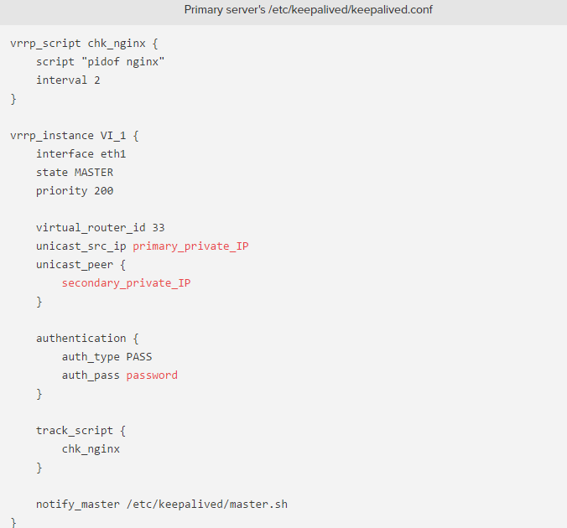

***Creating the Secondary Server's Configuration***

Next, we will create the companion script on our secondary server. Open a file at /etc/keepalived/keepalived.conf on your secondary server:



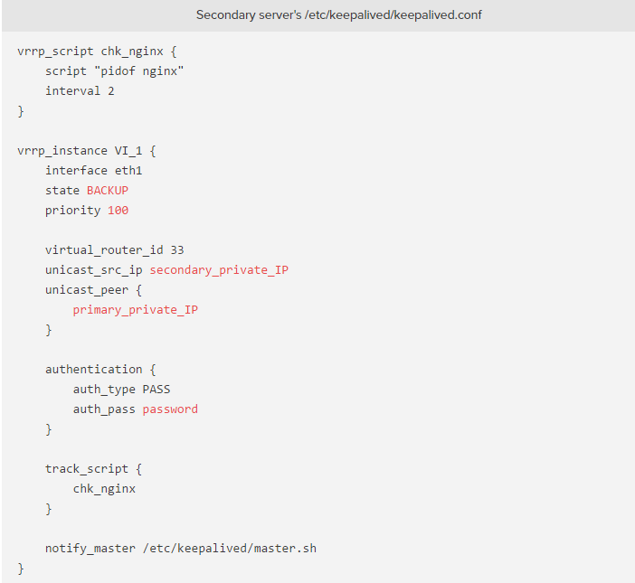

***Create the Floating IP Transition Scripts***

Next, we will need to create a pair of scripts that we can use to reassign the floating IP address to the current Droplet whenever the local keepalived instance becomes the master server.

Create a DigitalOcean API Token

In order to use the script above, we will need to create a DigitalOcean API token in our account.In the control panel, click on the "API" link at the top. On the right-hand side of the API page, click "Generate new token":

On the next page, select a name for your token and click on the "Generate Token" button:

Configure a Floating IP for your Infrastructure

Next, we will create and assign a floating IP address to use for our servers.In the DigitalOcean control panel, click on the "Networking" tab and select the "Floating IPs" navigation item. Select the Droplet from the list that you assigned as your "primary" server:

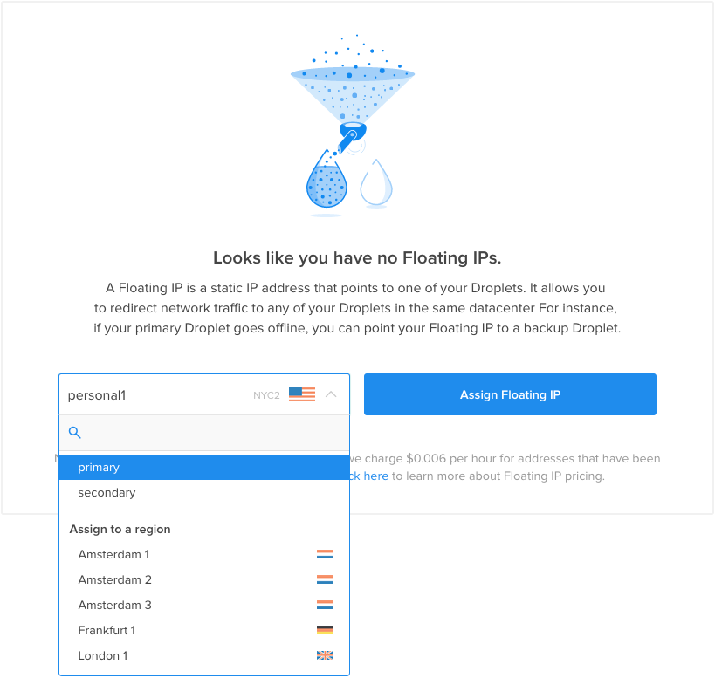

A new floating IP address will be created in your account and assigned to the Droplet specified: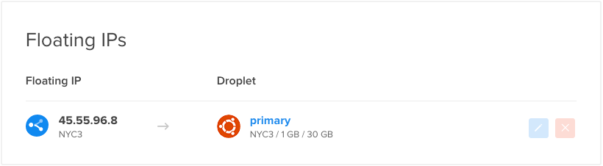

***Primary***

Copy the floating IP address down. You will need this value in the script below.

Create the Wrapper Script

Create the file now on both servers by typing:



Inside, start by assigning and exporting a variable called DO_TOKEN that holds the API token you just created. Below that, we can assign a variable called IP that holds your floating IP address:

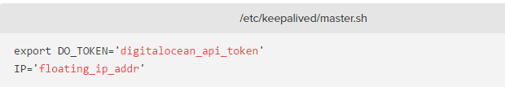

Next, we will use curl to ask the metadata service for the Droplet ID of the server we're currently on. This will be assigned to a variable called ID. We will also ask whether this Droplet currently has the floating IP address assigned to it. We will store the results of that request in a variable calledHAS_FLOATING_IP:

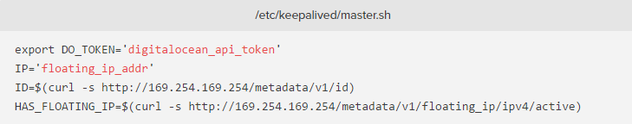

To handle cases where the floating IP already has an event in progress, we will retry the assign-ip script a few times. Below, we attempt to run the script 10 times, with a 3 second interval between each call. The loop will end immediately if the floating IP move is successful:

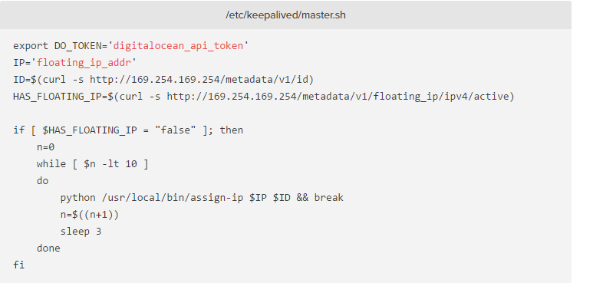

***Start Up the Keepalived Service***

The keepalived daemon and all of its companion scripts should now be completely configured. We can start the service on both of our machines by typing:



When both servers are healthy, if you visit your floating IP in your web browser, you should be taken to the primary server's Nginx page.

**SNAPSHOTS**

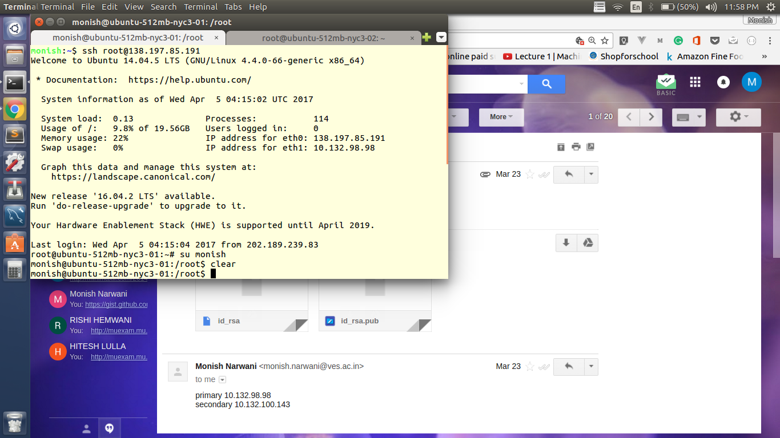

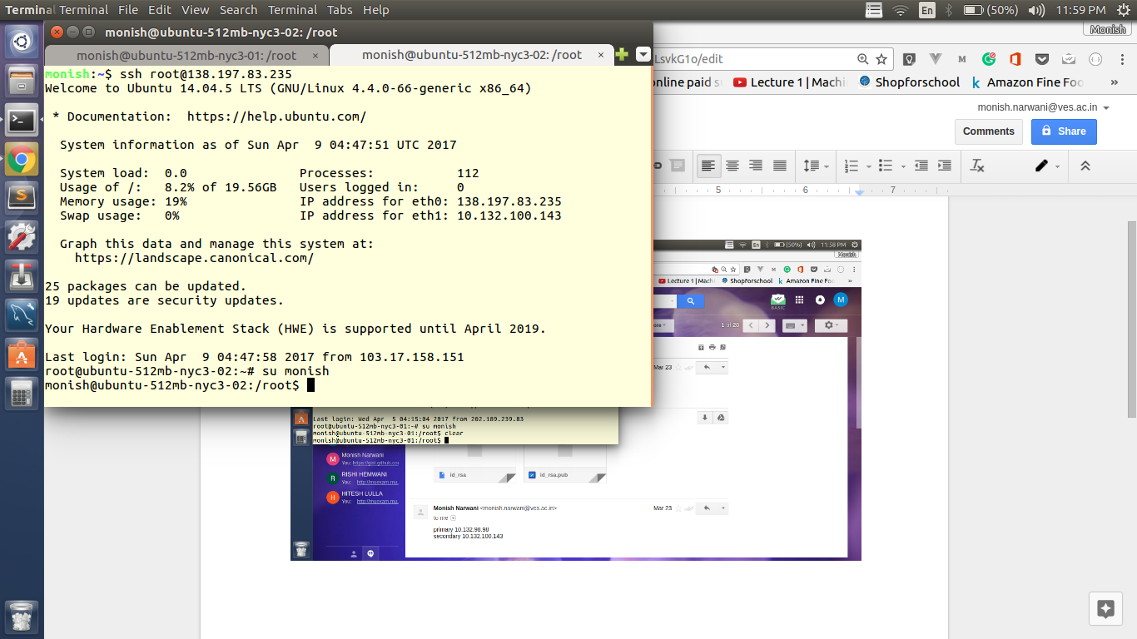

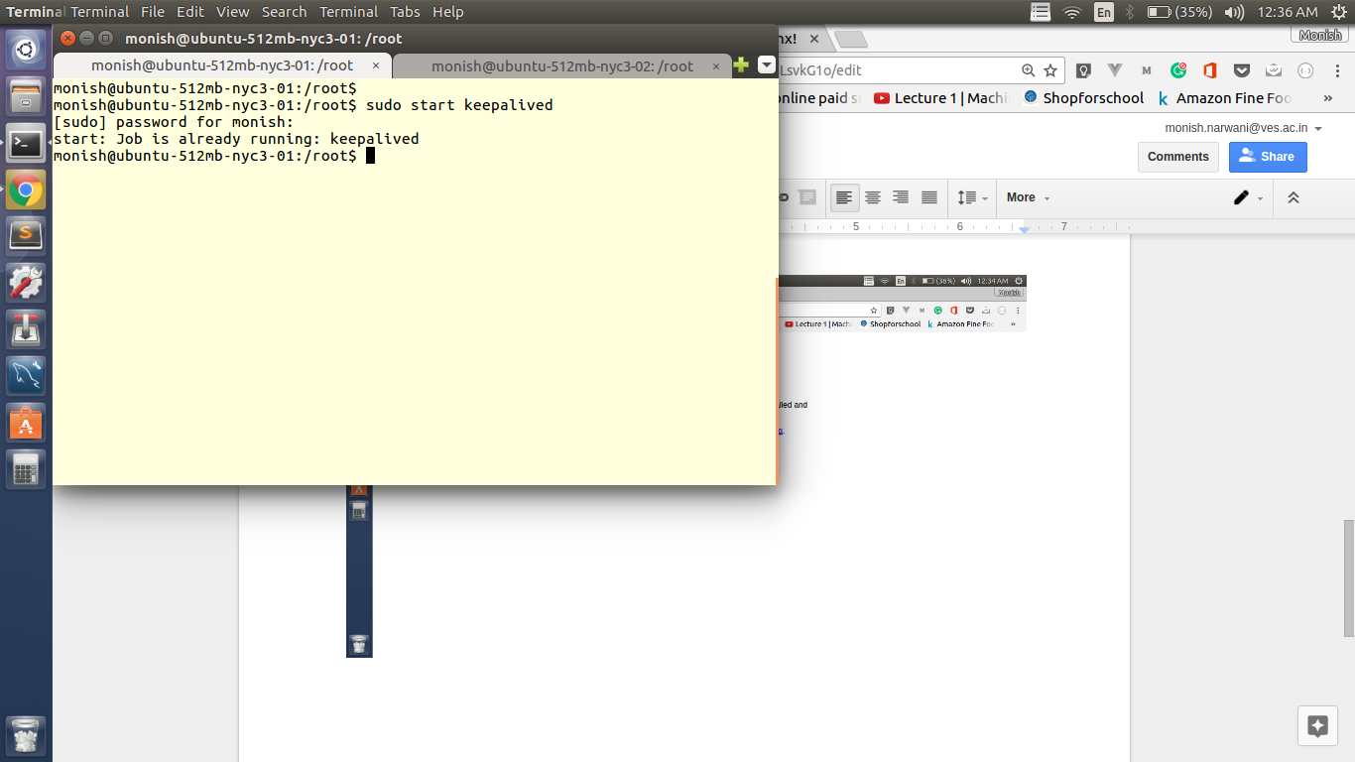

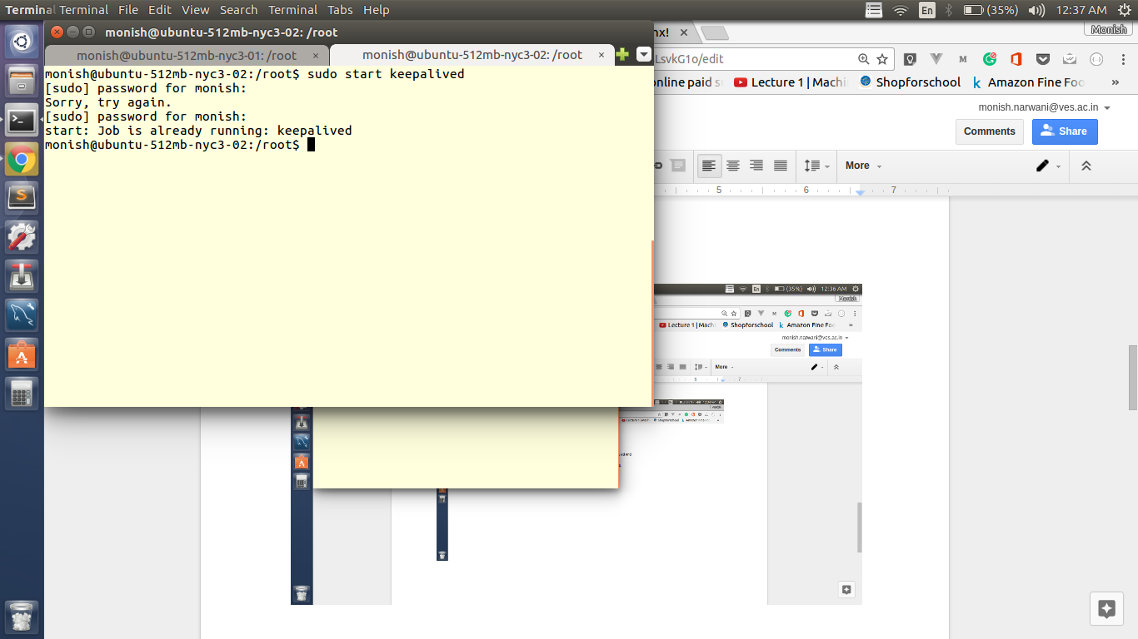

Floating ip: **138.197.55.80**

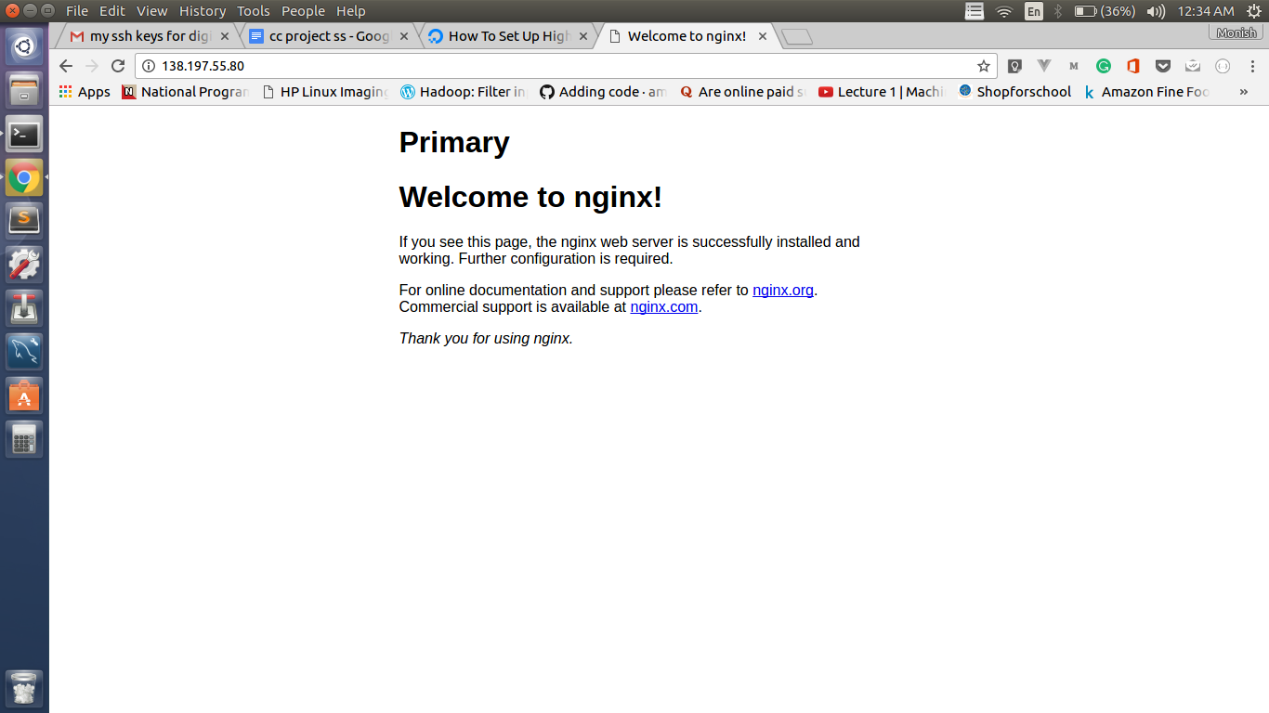

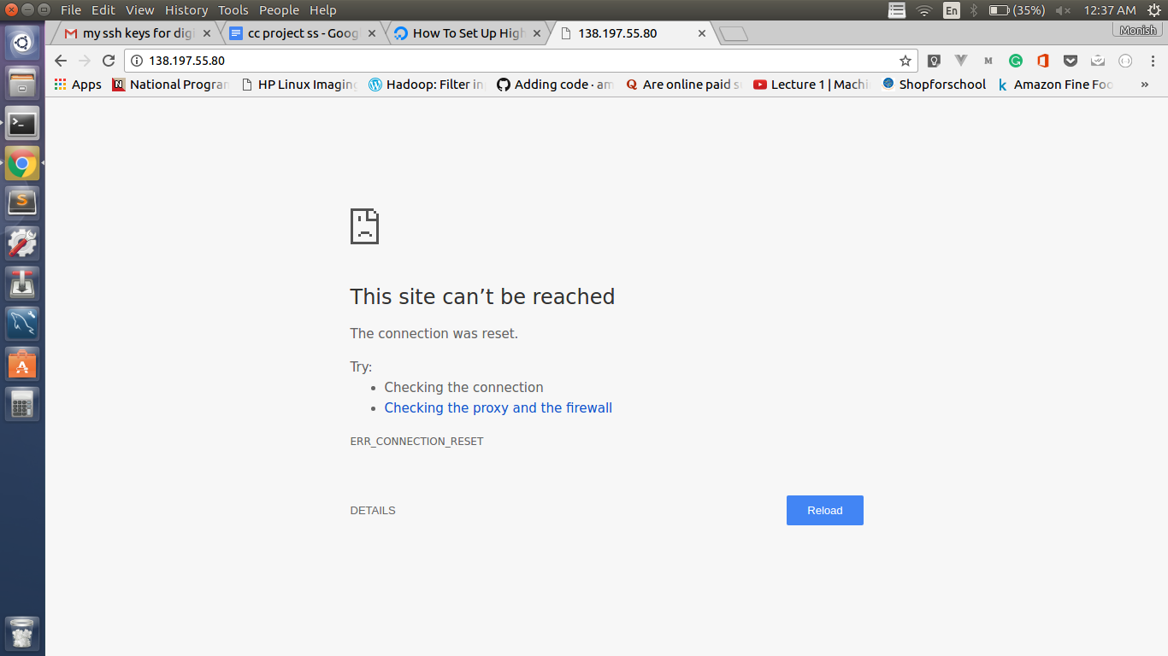

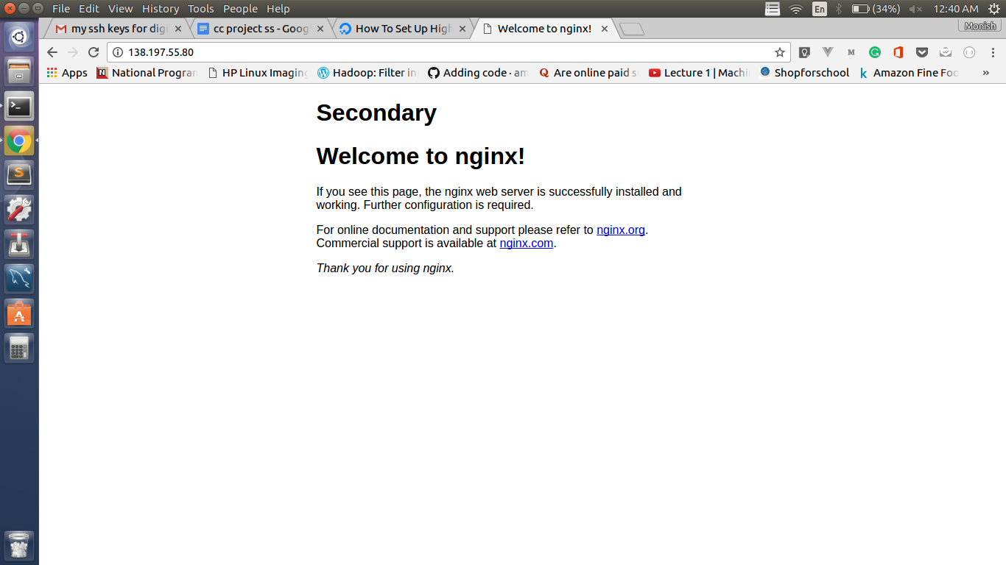

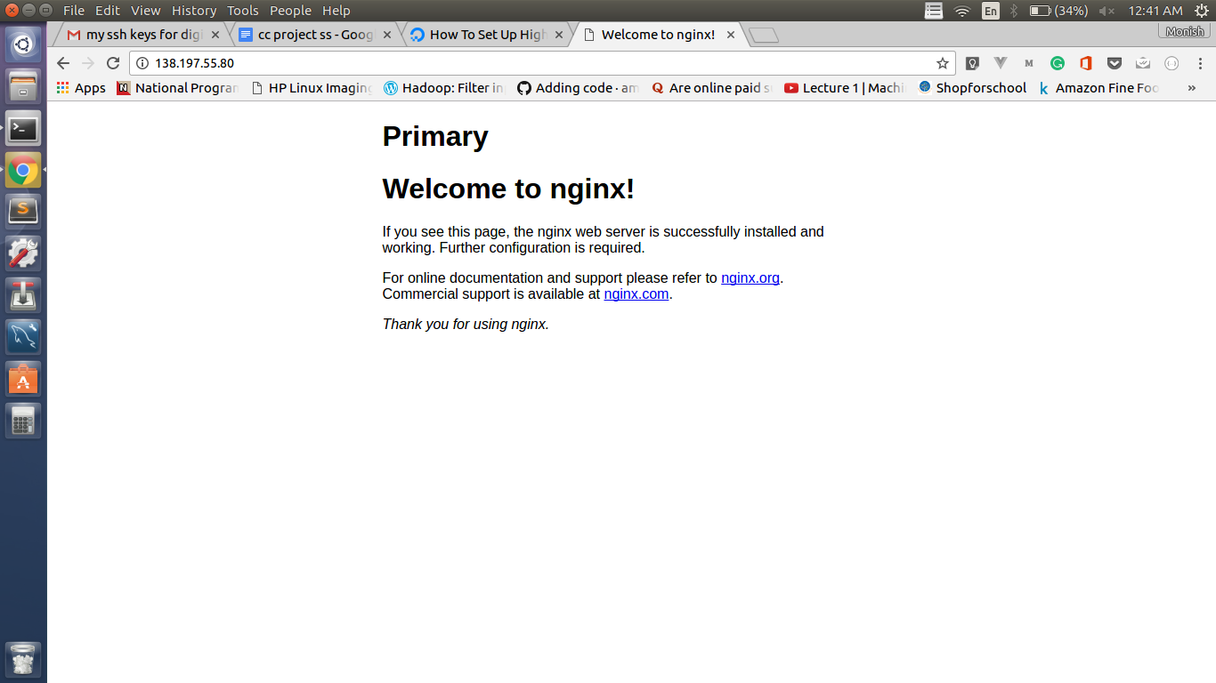

**CONCLUSION**

We configured a highly available web server environment using keepalived, the DigitalOcean API, and a floating IP address. The actual infrastructure was rather simple, but the concepts can be applied to any type of infrastructure where service availability and uptime is important.

**REFERENCES**

<https://www.digitalocean.com/community/tutorials/how-to-create-your-first-digitalocean-droplet-virtual-server>

<https://www.digitalocean.com/community/tutorials/initial-server-setup-with-ubuntu-14-04>

<https://www.digitalocean.com/community/tutorials/how-to-set-up-highly-available-web-servers-with-keepalived-and-floating-ips-on-ubuntu-14-04>